**Railway Reservation System**

This project is about the Railway Reservation System. A program for railway reservation is designed. The reservation system allows operations to book and cancel. In both cases, customers are required to fill the request form and present it to the clerk who enters the information on the computer screen. Assume that the reservation system is for one passenger per form only. The booking task involves checking availability, receiving payment and confirming the booking. Passengers may be put on the waiting list. For cancellation, the booking is checked, cancellation charges are calculated and a refund made. Cancelations may be made by confirmed or waitlisted passengers. It is designed such that cancelations made adjustments to the waiting list.

**Here, the root node is Railway Reservation. Booking and Cancel are two sub-nodes.**

**For Booking,**

* We must take passenger’s information, check availability, receive payment and confirm booking. Passenger’s Information need not be decomposed further as all the information will be collected and stored there for reference.
* **Check availability** is where the total number of seats will be counted and checked to see the number of seats that are filled or vacant. Vacant seats will be used for seat allocation and the passengers will choose their respective seats in the train compartment. If seats are not vacant, then the names will be incorporated into the waiting list. Therefore, Seats available and Waiting List are two components of Check Availability.
* **Receive Payment** is where payment can be received in cash, card or internet banking. These are the components of Receive Payment.
* **Confirm booking** is where once the payment is completed, the tickets will be issued and printed.

**For Cancel,**

* We must take into account Passenger’s information once again along with check booking, cancellation charge and refund. For Passenger’s information, details of the passengers are taken to tally and find out the seats they had booked previously.
* **Passengers must have the coupon code of the ticket to be cancelled.**
* **Check booking** returns the details of their seat-booking done previously.
* In **Cancellation charge**, 10% of the total amount that cost for seat booking is deducted if the seat had been confirmed previously, otherwise, for passengers whose name was on the waiting list, only 5% is deducted.
* In **Refund**, the remaining amount after the percentage charge cancellation deduction is returned back to the passenger.
* In **Update**, the seat availability chart is updated with the newly vacant seats and then cancellation is confirmed by printing.

**Cartesian Decomposition**

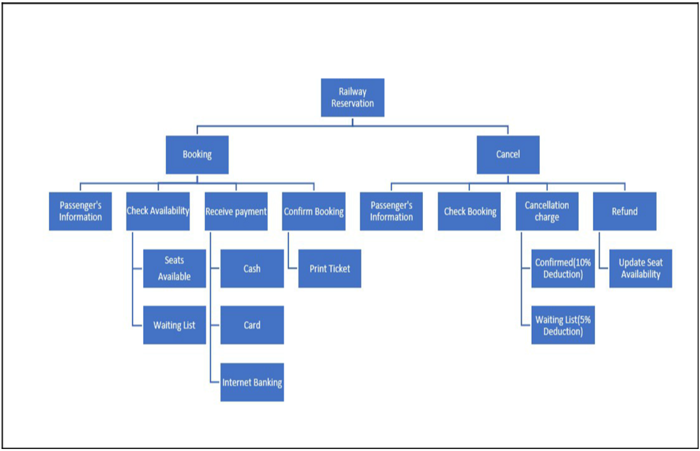

**Modular Structure**

